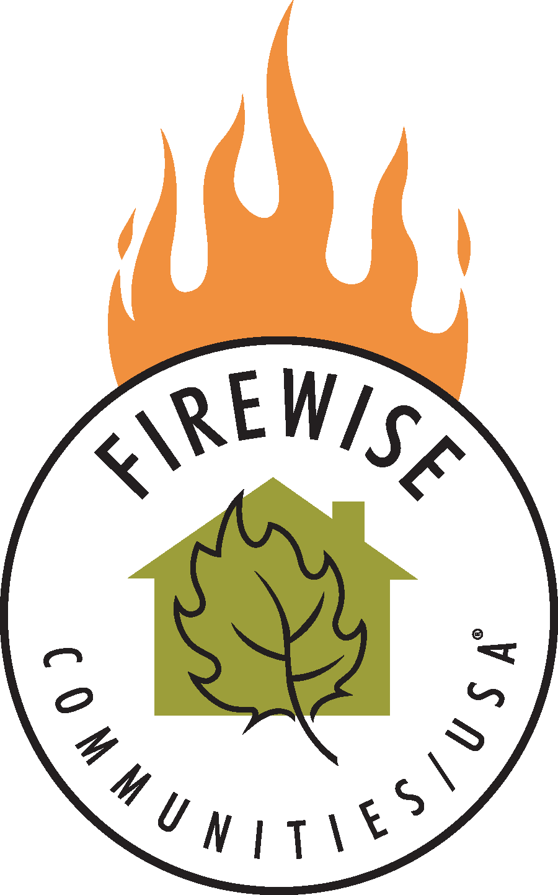

*We appreciate our resident’s efforts to keep their property safe and Firewise. Towards that end we offer you a celebration of all our efforts with the help of the Jerome Ukulele Orchestra, a BBQ. Let’s talk to our neighbors and friends about keeping Jerome an Active Firewise Community!*

**Where:** Jerome Fire Department

**When:** Saturday, May 4 from 10 am to 2 pm

**Details**: Hot Dogs, Hamburgers, Soda’s & Chips will be available as well as some fun for the kids!

Live Entertainment by Jerome Ukulele Orchestra!

Jerome Firewise Community Appreciation Day  
Drop by the fire station for information, entertainment, hotdogs & hamburgers!

**Saturday, May 4, 2019**